**Robby**

User Manual

**General Information**

The game created was created with the intention of turning the logic behind the mechanics of the game, into visuals through the graphics.

**Target Audience**

The game for anybody who wishes to get involved with game development with the aim to help give some examples of logical components used in games.

**Game Controls**

W = Move Forward

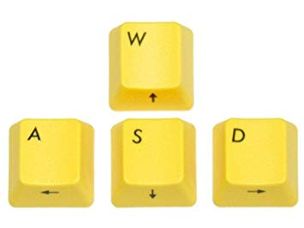

S = Move Backwards

D = Move Right

A = Move Left

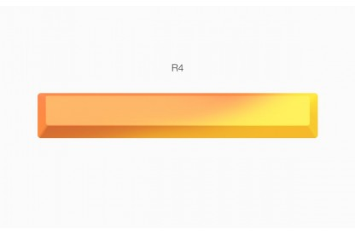

Spacebar = Jump

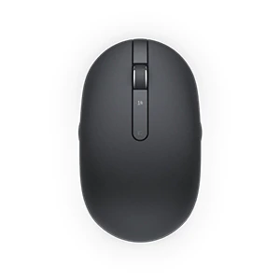

Mouse = Look Around

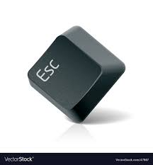

Esc = Returns the player to the Main Menu

**The Game**

Main Menu

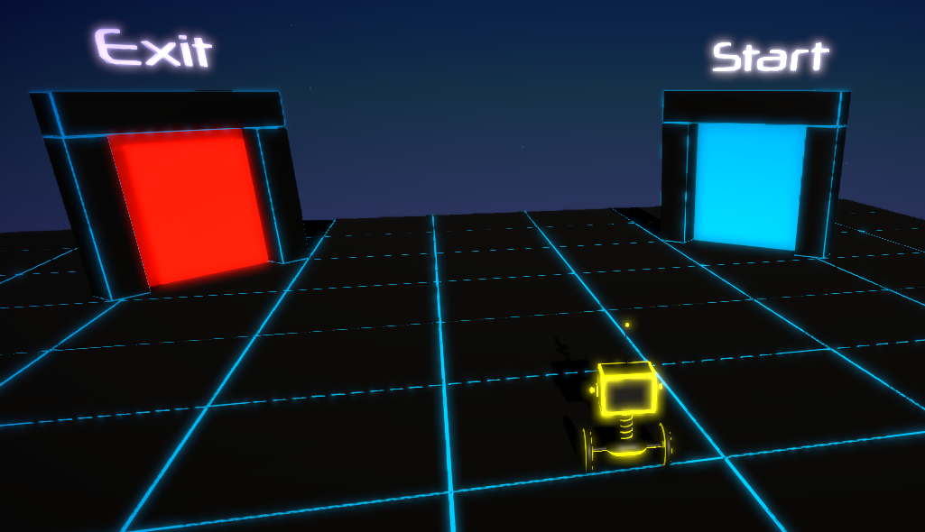

Here the player is presented with a playable Main Menu.

The player here has 2 choices Exit to quit the game and Start to start the playthrough. When the player presses the Esc key this is the scene he will be returned to.

Logic puzzles

In the first level the player is presented with a simple Boolean puzzle where they have to pick True or False, picking the right platform will turn on the portal to the next level.

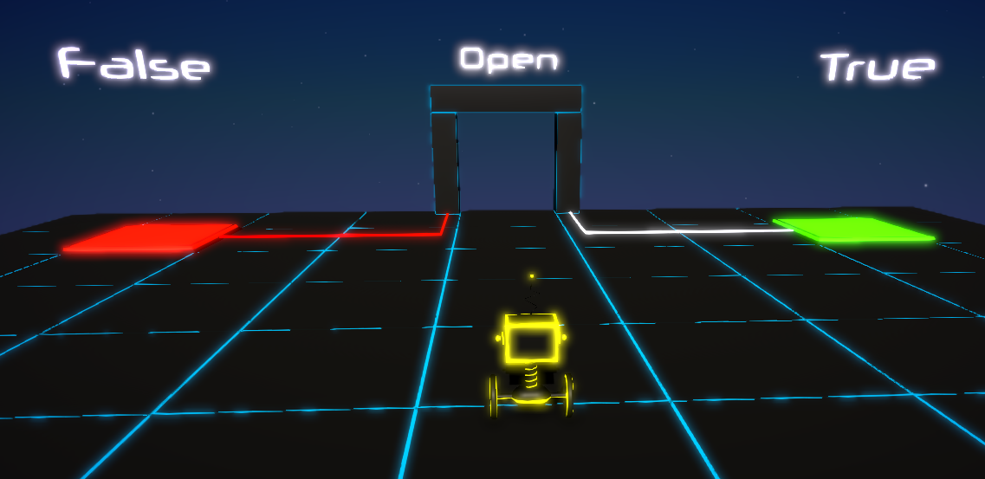

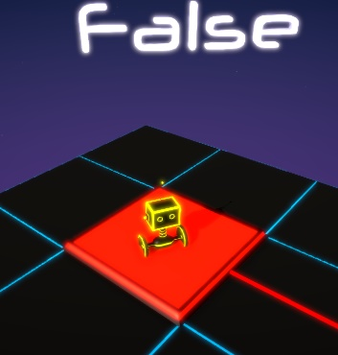

The red platform represents the false value.

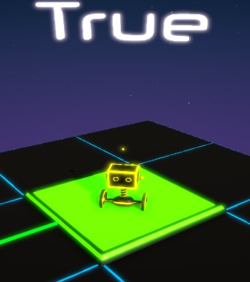

The green platform represents the true value.

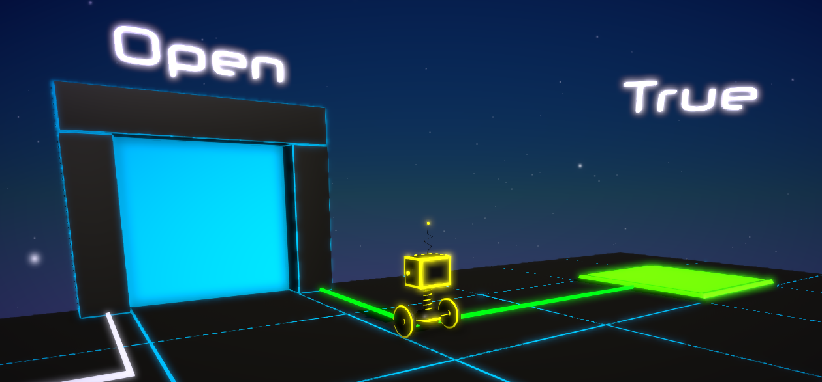

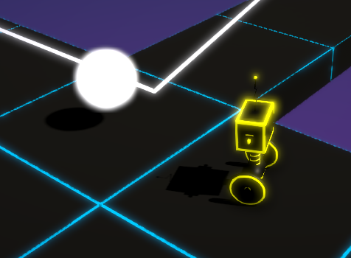The portal appears when the right platform is used.

Through the levels white spheres can be found which will animate the tiles used to build the levels to create ramps.

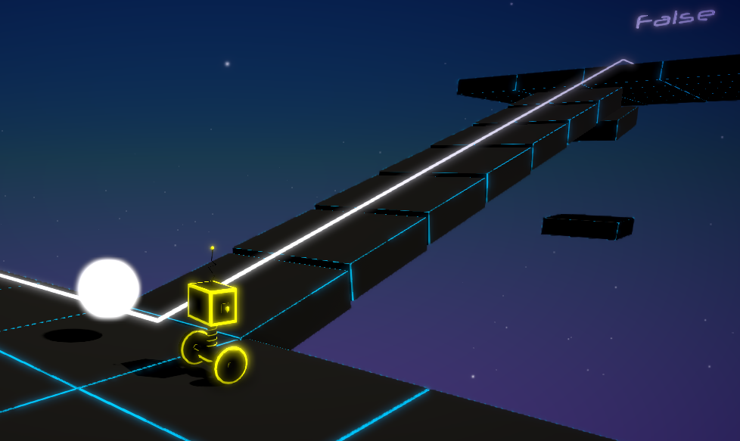

To be able to get to higher ground and across larger gaps the player will also encounter floating platforms.

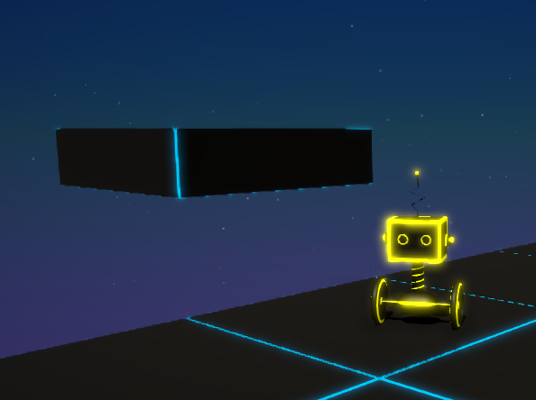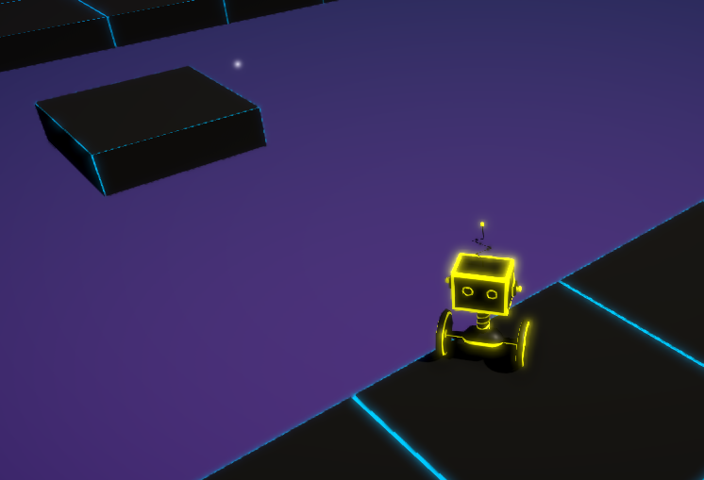

As the player progresses through the levels the map manipulation will increase, this will provide the player with more challenging puzzled as they progress through the game.